**CIS 375 – Fall 2019 Term Project - BRAINS**

Use Case Specification Document

**6**

**Users and Departments Management**

**Version No. 1.0.0**

Project Document Revision History

|  |  |  |  |
| --- | --- | --- | --- |
| VersionNumber | Date | Revision Author | Description of Revision |
| 1.0.0 | 10/29/19 | Cameron Labut | Creation of document |
|  |  |  |  |

|  |
| --- |
| **Table of Contents** |

1. Introduction 4

2. Use Case Information 4

2.1 Actors 4

2.2 Use Case Interaction 4

3. Trigger 4

4. Pre-condition(s) 4

4.1 Users must exist first to be added to the company/department. 4

5. Post-condition(s) 4

5.1 User is added 5

5.2 User is removed 5

5.3 Department is added. 5

5.4 Department is removed. 5

6. Use Case Swimlane (Activity) Diagram 5

7. Main/Basic Flow(s) of Events (Happy Path) 6

7.1 User is added 7

7.2 User is removed 7

7.3 Department is removed 7

7.4 Department is removed 7

8. Alternate/Exception Flow of Events 7

9. Assumptions/Business Rules including Non-Functional Requirements 7

10. Use Case Specification Review and Signoff 7

# Introduction

This use case is for the adding, removing and otherwise managing users and departments within the system. Users are given credentials depending upon their rank/job within the company. Departments are added in a similar way after all of their constituent users have been created.

# Use Case Information

## Actors

An actor is someone or something (e.g. application system) outside the system or business that interacts with the application. For every Use Case, there must be at least one Main Actor and zero or more Secondary Actors. Actors should be a person, system, or time.

|  |  |  |
| --- | --- | --- |
| Actor Name | Role | Description |
| Oversight Team | Main | Can create, move and administrate users, and update the rosters of, departments. |

## Use Case Interaction

How does this use case relate to other uses cases? List predecessor and successor use cases.

Predecessors:

Successors:

Purgatory:

Use Case 2: ~

Users can be added or removed at any point if their employment changes with the company, thus this is both a predecessor and successor use case. Similarly, with department management, departments can be modified at any point if the project triangle for that particular department’s project changes, e.g. if they need new users moved from elsewhere.

# Trigger

The moving of users from one department to another, the moving of users into, out of, and within the company, the closing of departments, the opening of departments.

# Pre-condition(s)

What use cases or other pre-conditions must be met before use can initiate?

## Users must exist first to be added to the company/department.

# Post-condition(s)

What are ALL the possible output states upon completion of the use case flows?

## User is added

## User is removed

## Department is added.

## Department is removed.

# Use Case Swimlane (Activity) Diagram

Draw diagram(s) that cover ALL main and alternate flows.

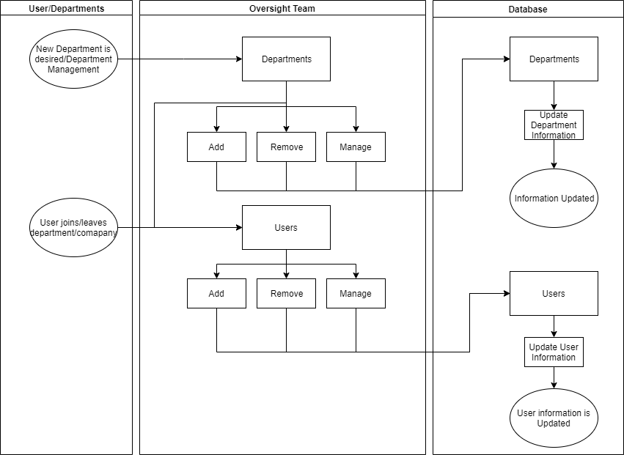

# Main/Basic Flow(s) of Events (Happy Path)

For each main flow (usually ONE flow) write the list of steps that occur – describe WHAT occurs not HOW to do it!

## User is added

* User joins company, is added to database and assigned a department.

## User is removed

* User leaves company, is removed from database and department.

## Department is removed

* Need for a new department – department is added to database and assigned >=1 user(s).

## Department is removed

* Department closure – Users are reassigned to other departments or given the boot.

# Alternate/Exception Flow of Events

# Assumptions/Business Rules including Non-Functional Requirements

Assume that users are already credentialed properly before being added to the company (their permissions to databases and the like) and that their credentials will be revoked in the event of their departure.

# Use Case Specification Review and Signoff

|  |  |  |  |  |
| --- | --- | --- | --- | --- |
| Review and Signoff of the Use Case Specification | | | | |
| Name | Project Team Role | Signature | Date |
| Ahmed, Zakariya | Senior Tech Lead/SPMP manager |  | 10/29/19 |
| Alhaidar, Muaz | Developer |  | 10/29/19 |
| Longworth, Kevin | Developer |  | 10/29/19 |
| Labut, Cameron | Developer | C.L. | 10/29/19 |
| Majzoub, Mostafa El | Developer |  | 10/29/19 |

# 